**Contents**

USER MANUAL PAGE 2

1.TICKET 2

2.Cabin Baggage Allowance 3

3.Seats 4

4.Membership point 5

5.Discount 6

# USER MANUAL PAGE

## 1.TICKET

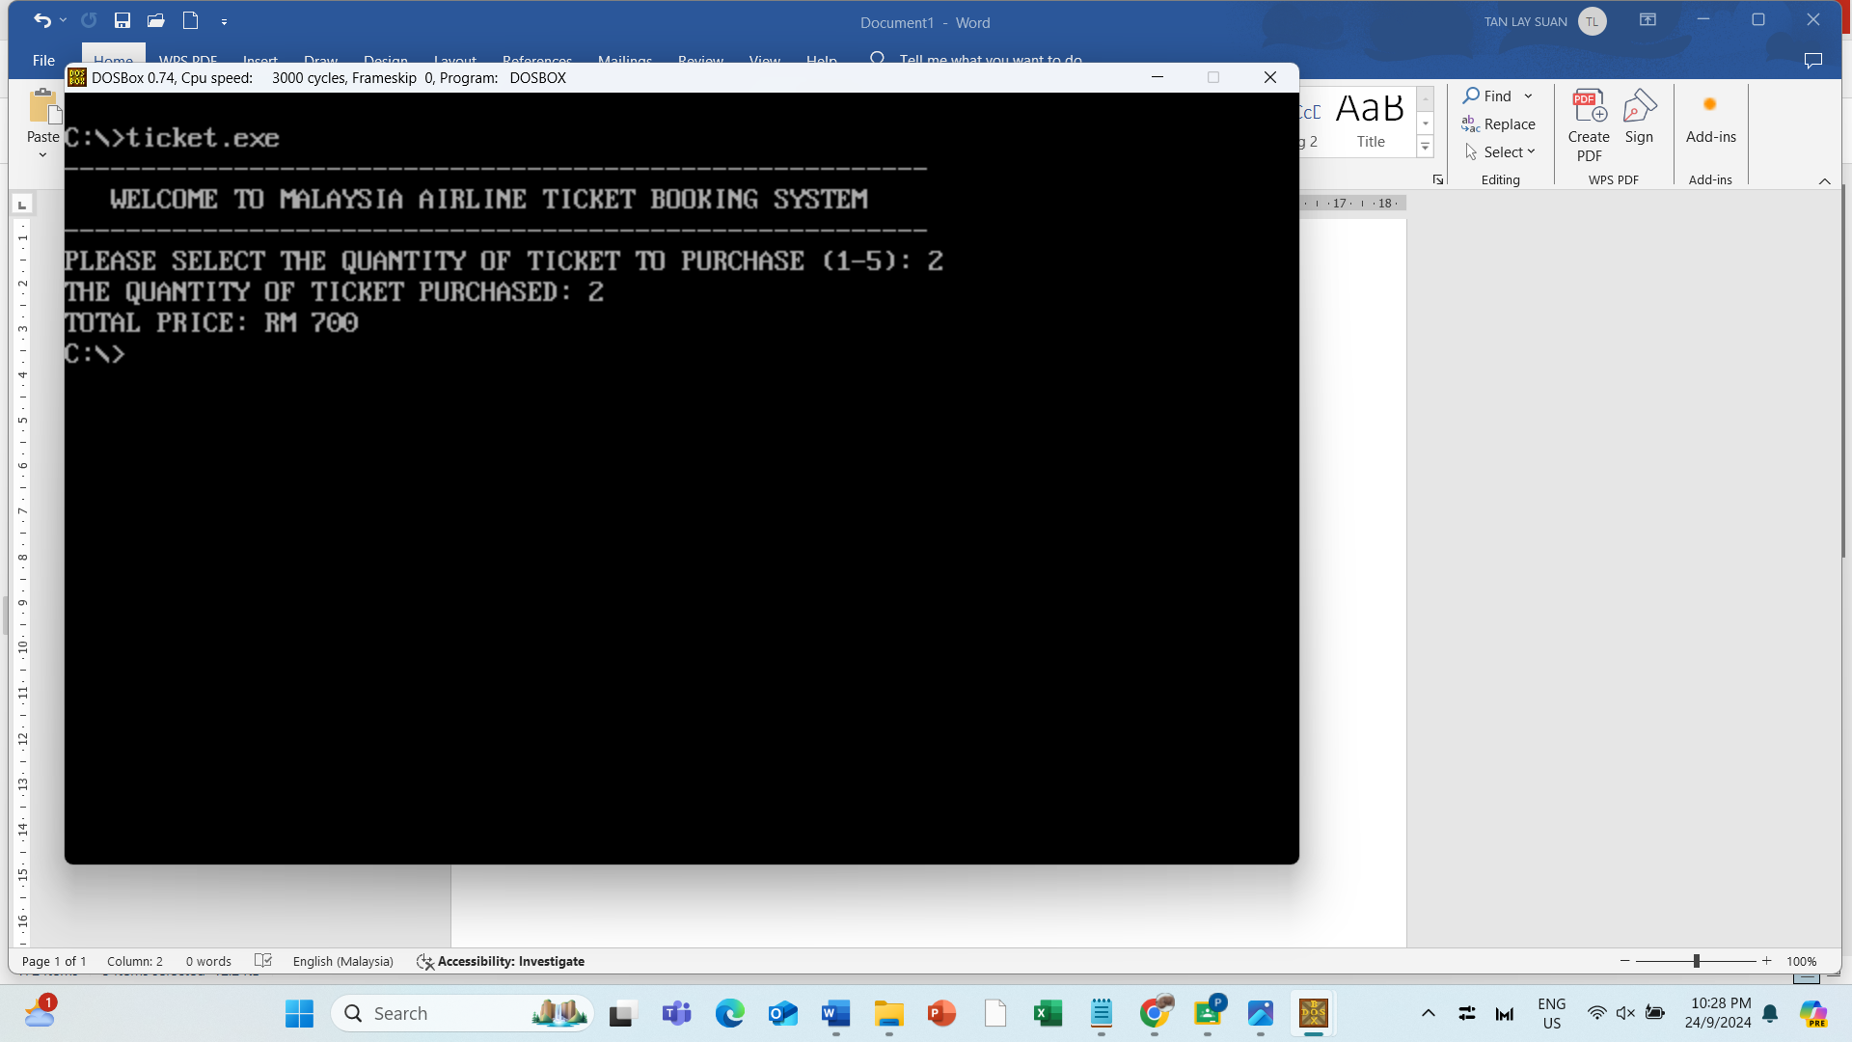

Firstly, the system will prompt a welcome message which is “Welcome to Malaysia Airline Ticket Booking System” to our customer . After that, the system will prompt a message to let the customer to select the quantity of airline tickets that they want to book from 1 to 5. If the customer enters an invalid quantity which is less than 1 or more than 5, , the system will prompt an error message to let the customer to reenter. For example, if the user chooses to buy 2 tickets, the user needs to enter 2. After choosing the quantity of tickets the system will calculate the total price of the ticket including service tax and handling fee. The price of each ticket is RM 300, the handling fee is RM50 and the service charge is RM50. Lastly, if the input is valid, the system will show the quantity of tickets bought by the customer and also will show the the total price needed to pay by the user.

## 2.Cabin Baggage Allowance

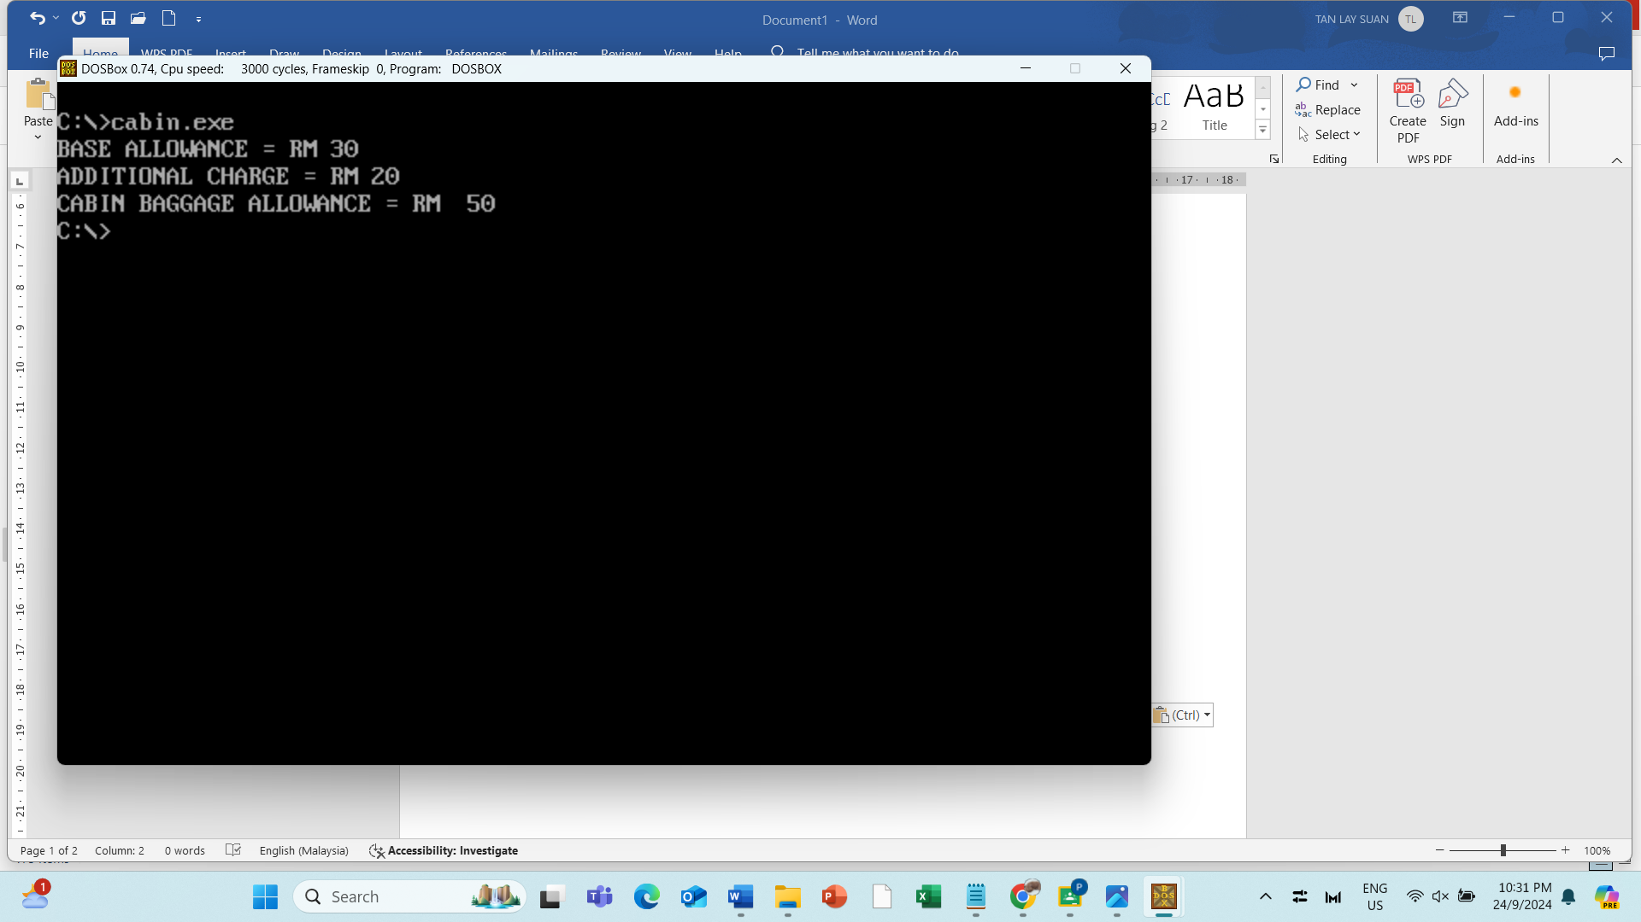

The next process is to calculate the cabin baggage allowance. The system will first prompt out the message of base allowance to show that the allowance is RM30. Then a new line will be created to make the output more readable. After that, an additional charge message will be prompted to show that there is an additional charge of RM20. Then, a new line will be created again. A message of cabin baggage allowance will then be displayed. Then, the system will start to calculate the total allowance by adding the base allowance with the additional charge. After calculation, the system will convert the total allowance to ASCII code before displaying the result. After converting, the system will then display the output.

## 3.Seats

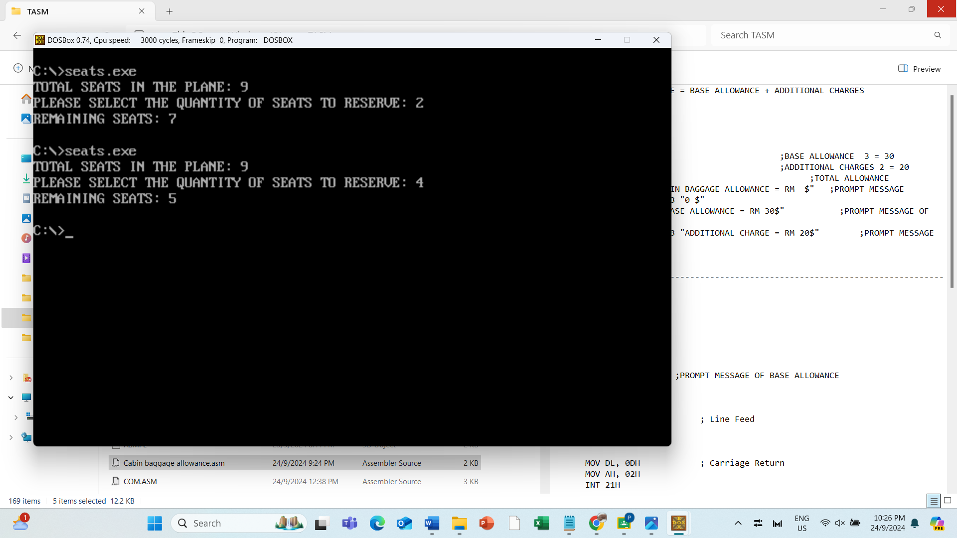

The next process after selecting the tickets to be purchased is seat selection. Seat selection is an important part of the purchase ticket process where passengers can choose their preferred seats on the plane. First of all, the system will prompt a message " TOTAL SEATS IN THE PLANE: 150" that shows the total seats the customer can reserve. Then, the system will prompt a message "PLEASE SELECT THE QUANTITY OF SEATS TO RESERVE: "which requires the customer to specify the quantity of seats they wish to reserve because the system needs to verify that enough seats are available for the amount specified. For example, a customer selects 2 seats to make the reservation. However, the calculation of remaining seats is the number of total seats in the plane deducting the number of seats that customers reserve. In this scenario, 7 is the remaining seats in the plane as 9 minus 2 is equal to 7. Therefore, a message "REMAINING SEATS" with 7 remaining seats are shown in this scenario.

## 4.Membership point

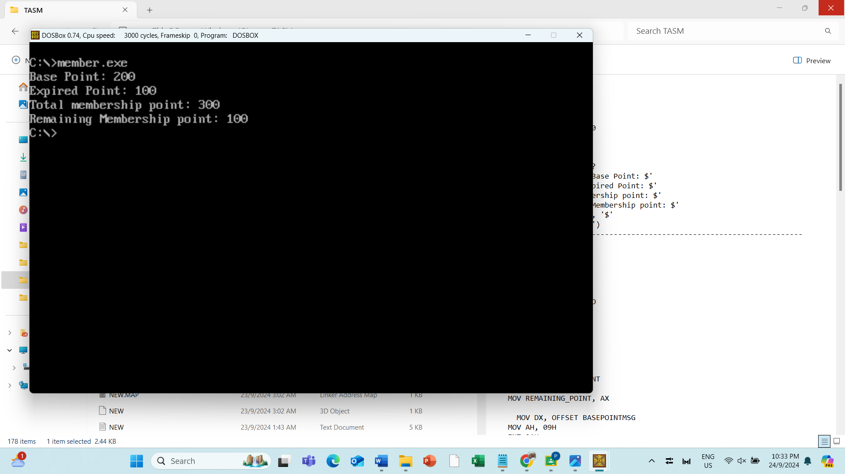

The next process is to calculate total membership point and remaining membership point. First of all, the system will prompt out "Total membership point" and "Remaining Membership point" message to inform the user what is the upcoming output will represent. Then, the system will start to calculate total membership point by adding base membership point and extra earn points and subtract used membership points, which is 200-points, 200-points and 100-points. At the same time, the system will proceed to calculate remaining membership point by subtract total membership point, used membership point and expired membership point, which is 300-points, 100-points and 100-points. After system finish doing the calculation, it will show result of total membership point is 300-points and remaining membership point is 100-points.

## 5.Discount for Business and Premium business class

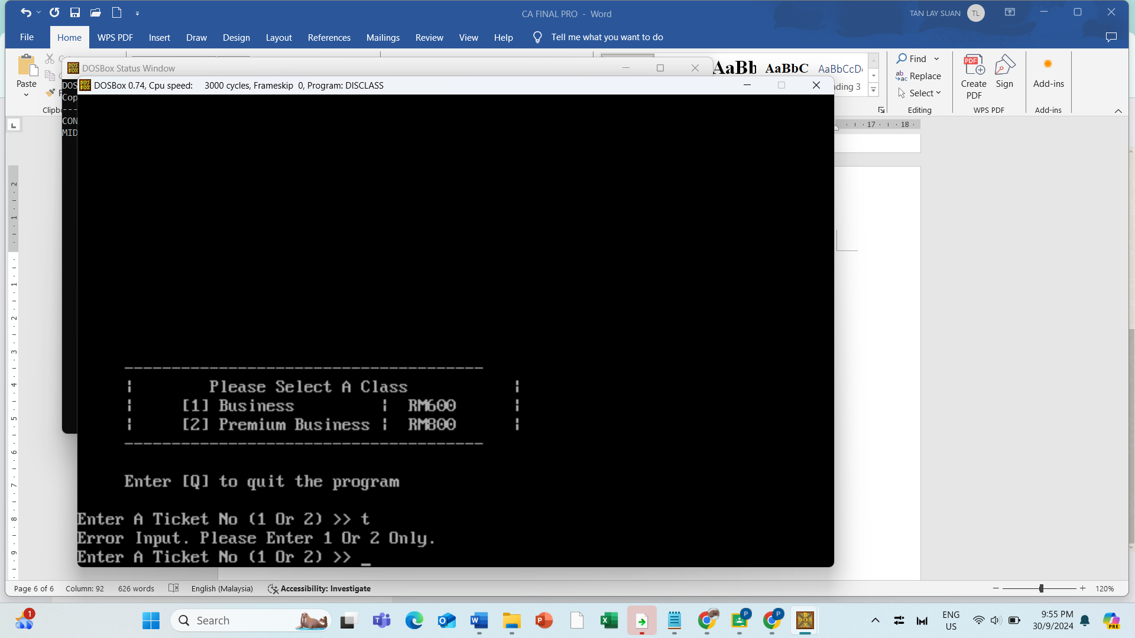

This discount is given to customers who purchased business or premium business ticket only. User may enter the input [1] or [2] in order to select the class of ticket. If user input others than [1] or [2], system will prompt out a message to ask user re-enter. Besides, system provide a chance to let user select to quit program if accidentally pressed.

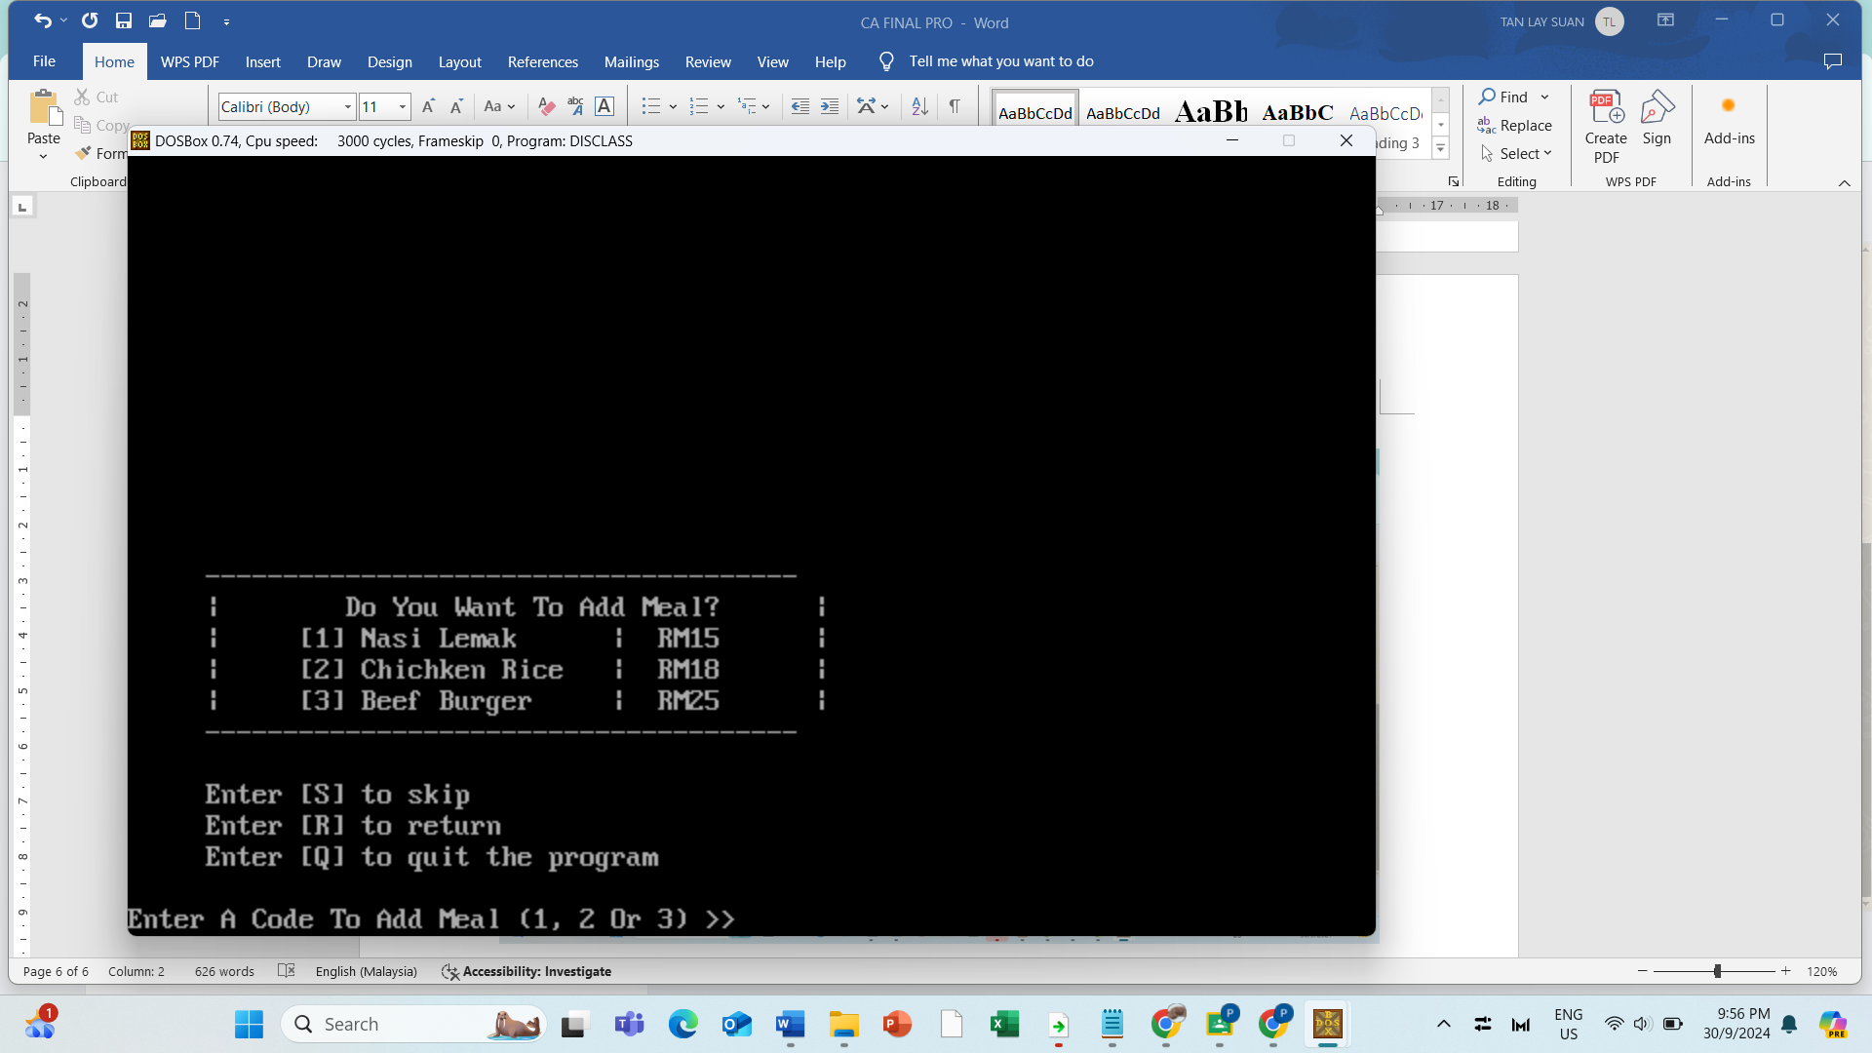

After the class selection, users may select to add on meal. Our company provide 3 types of meal to select. User may enter 1,2 or 3 for meal selection while user may also press [S] to skip for meal selection, [R] to return class selection and [Q] to exit the whole program.

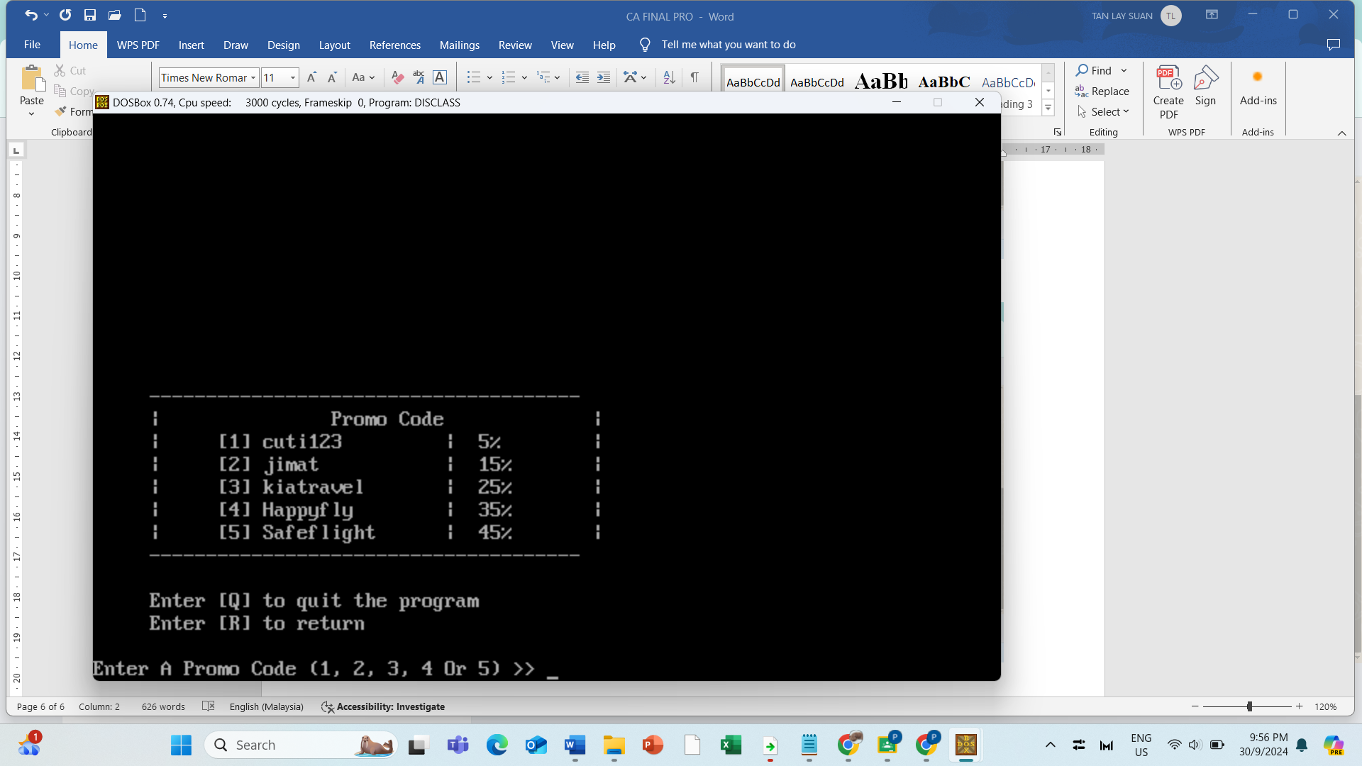

Continue with the Promo code page, user can enter a number [1-5] to select the promo discount.

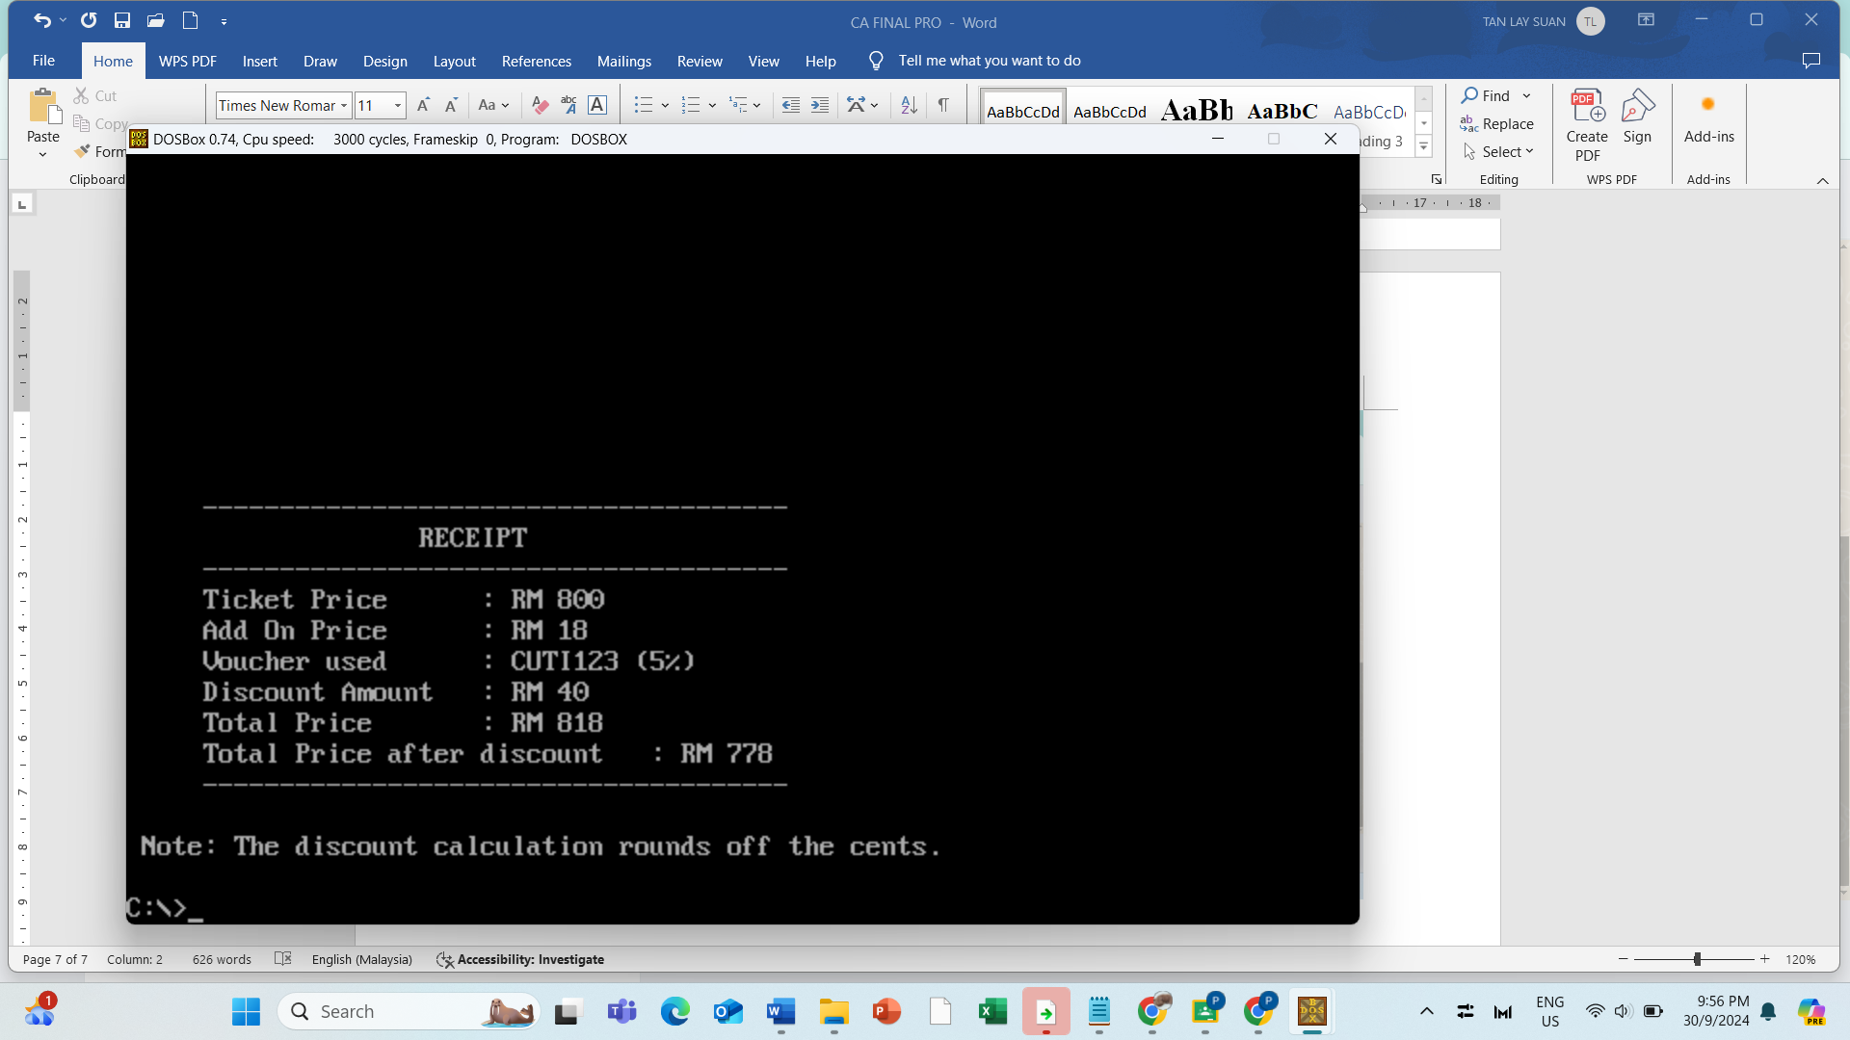

Hence, this is the receipt shows that the chosen ticket price, meal price, voucher used, discount amount from the chosen voucher, total price before discount and total price after discount.